Develop code for classes to read and analyze binary data.
Write a function named selection_sort() which takes two parameters, a integer pointer and an integer size. Add code to implement a selection sort algorithm. Add any needed functions to support the selection sort.
Write a helper function named binary_search that takes three parameters, the first is an integer array, the second is the searched for value, and the third is the array size. This function calls the recursive function and passes the array, the search value, the starting index, and the last index.
Write a recursive function named binary_search_recursive() which takes four parameters passed from the helper function. The first is an integer pointer representing the array of values, the second is an integer representing the value to be searched for, the third is an integer for the starting index, and the fourth is an integer for the ending index.
Add a new class named SearchAnalyzer which subclasses Analyzer and implements the analyze() method. Use the override keyword appropriately. The constructor should first call the selection_sort() function, passing the integer array and the size. In the analyze() method, generate 100 random integer values in the range of 0 to 999 and use the binary_search() function to see if that value exists in the data. Count the number of found values and return the count in a std::string.
Modify the StatisticsAnalyzer analyze() method to call the selection_sort() function. Alter the computation of the minimum and maximum values considering that the array is sorted. Add functionality to implement the median and mode averages using the sorted data. The median is the exact middle value (if there are an odd number of elements) and the mean of the two middle values (if there are an even number of elements). The mode is the most frequently occurring value; if more than one value occurs with this frequency, pick the first one.
Write and debug the above parts ensuring that each part works, that it compiles with no errors or warnings, and that the results look like the Part4 output. Note: your values will vary, although most of the results should be similar.

Use these function and class headers:
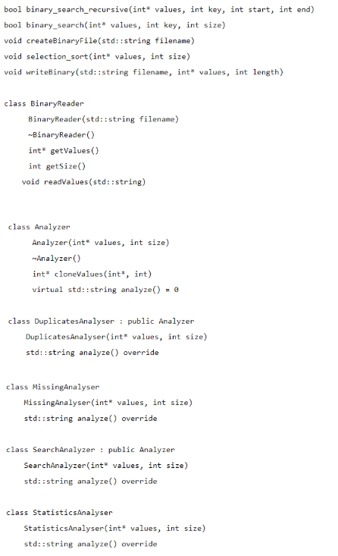

Grading
Your completed assignment is worth 200 points and is due Saturday by 11:59 PM PST.
- Each team member must submit the group project separately and list the name of other members in the submission file. Create a single zip file containing your Visual Studio project folder and pseudocode document. Name the zip file using the following convention – FirstNameAssignmentNumber. Example: SmithJohnAssignment5
- Each team member must submit the completed peer evaluation form.

